Network Architecture and Protocol Lab

Booklet 2
Submitted by: Jamil Ahmed
Neptun Code: JZT75Y

4.1
A. Characteristics of Coaxial cable
- Diameter: RG-58 coaxial cable diameter ≈ 5 mm
- List of connector types: Common connectors used with coaxial Ethernet cables:
  - BNC connector
  - BNC T-connector
  - BNC barrel connector (coupler)
  - 50 Ω terminator
- Length of connector (coupler) to NIC: ≈ 35 mm

B. Characteristics of Twisted-pair cable
- Diameter: Outer diameter of Cat5e UTP cable ≈ 5.5 mm
- List of connector types: Main components of a RJ-45 connector:
  - Plastic RJ-45 connector body
  - 8 gold-plated contacts (pins)
  - Cable strain relief
  - Plastic locking tab (clip)
- Length of connector (coupler) to NIC: ≈ 21 mm

C. Characteristics of Optical cable
- Diameter of outer plastic jacket: ≈ 3 mm
- List of cable types according to length in increasing order:
  - Multimode fiber OM1
  - Multimode fiber OM2
  - Multimode fiber OM3
  - Multimode fiber OM4
  - Single-mode fiber (SMF)
- Diameter of plug (ceramic/metal) submodule: 2.5 mm ceramic ferrule.
4.2 Decibel and Power Ratio Calculations
A. Converting power ratio to decibels:
x = 12, dBs = 21.58
x = 14, dBs = 22.92
x = 16, dBs = 24.08

B. Converting decibels to power ratio:
dBs = 13, power ratio = 4.46
dBs = -68, power ratio = 0.000398
dBs = -70, power ratio = 0.000316

4.3
A. Properties of Oracle VM VirtualBox
- Version Number: VirtualBox 7.2.6
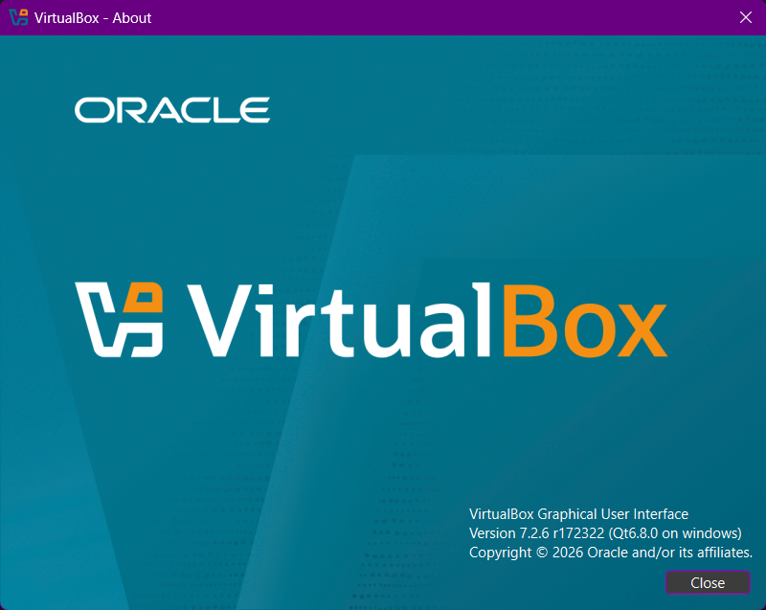
- Number of possible VM types: VirtualBox allows many operating system families.
  - Windows
  - Linux
  - BSD
  - IBM OS/2
  - Mac OS X
  - Other
Each type contains multiple versions such as 32-bit and 64-bit.
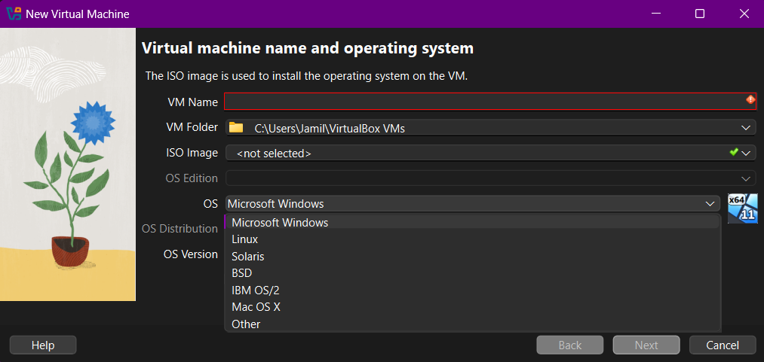
- Possible types of VM network interfaces:
  - NAT
  - Bridged Adapter
  - Host-Only Adapter
  - NAT Network
- Possible number of VM network interfaces: Up to 4 Adapters.

B. File Structure Properties of VirtualBox
All virtual machines are stored as files on the host operating system. The host system stores VM files, while the guest operating system accesses virtual hardware provided by VirtualBox. It is possible to create shared folder which can be accessed by both host and guest system.

